INFO 4707 TERM PROJECT: GROUP #7

Sariah Ogbe

Ayinde Feranmi

Sana Mhapsekar

Rista Haque

**Health Insurance Member Management System**

**INTRODUCTION**

Healthcare has a constant demand in society and applies to most of the population. With the growing need for healthcare, it is necessary to find ways to organize and update insurance policies with ease. Data is constantly growing and changing and through this database system we hope to make insurance information easy to manage for all. This database allows for convenient user and administrative access to edit and utilize insurance policies. With the features and accessibility of this system, the issue of healthcare insurance management and flexibility will become a thing of the past.

**PROJECT SCOPE**/**OBJECTIVES:**

* To manage and store growing data relating to user insurance policies.
* The ability to store and view the history of health insurance policies.
* Administrator access to create and update new policy changes and options.
* Create member access to manage elections.
* To seamlessly integrate dataset with other systems within the Organization, such as a Claims processing system, billing systems etc. to ensure data accuracy and streamline automation.
* Guarantee adherence to compliance regulations and standards, such as HIPAA, which governs how healthcare data is managed.
* Create a centralized database where members’ information including enrollment details, policy information, etc. can be accessed easily.
* To ensure the security and integrity of sensitive information, which includes Personal Health Information and financial transactions.
* To provide web and mobile interface which allows policy holders convenient access to information and claims.
* Provide training and support for users to ensure they can effectively maneuver through the systems.
* Incorporate automated alerts and notifications systems to inform stakeholders of major events, deadlines of claims and policies.

**USER REQUIREMENTS**

* Ability for members to view details of their insurance policies, including coverage, benefits, limitations, and exclusions.
* Options for assigning Group administrators to manage groups.
* Ability for members to be notified of policy changes, such as renewals, new exclusions, and other plan changes.
* Integration with enrollment processes to facilitate plan selection and enrollment for members.
* Secure storage of sensitive member data (PHI) in compliance with HIPAA privacy regulations.
* Integration with the organization’s claims processing system to ensure accurate handling of excluded services.
* Ability to manage exclusions based on updates to medical guidelines and regulations.
* Ability to integrate with other systems within the organization, allowing them access to members’ data for different functionalities.
* Support for defining eligibility criteria based on a member’s personal information.
* Support for dependent changes.
* Generation of reports to monitor KPIs such as enrollment rates, member retention, financial metrics, etc.
* Management wellness incentives/ programs offered to members.
* Real-time access for members to track the status of claims, including submission, processing stages, and final resolution.
* Customizable communication preferences for members, allowing them to choose how they receive notifications (email, SMS, app notifications) about their policy, claims, and program updates.
* Provision for members to submit feedback on insurance services and wellness programs, including a mechanism for addressing grievances and suggestions for improvement.

**BUSINESS RULES**

* + Each member must be enrolled in at least one plan.
  + Each member has a unique member ID.
  + The policy holder may have multiple dependents, such as spouses or children.
  + A member can be enrolled in multiple incentive programs.
  + The enrollment status of a member can be active or Inactive.
  + Each plan can have multiple enrollments.
  + Each plan can have multiple exclusions. Each exclusion corresponds to at least one plan.
  + Exclusions define specific medical conditions or treatments not covered by the plan.
  + Groups may consist of multiple members enrolled under a single plan.
  + A group must have at least one plan.
  + Multiple plans can belong to the same group.
  + Each enrollment is associated with one member’s plan.
  + Termination dates must be recorded accurately to reflect the last day of coverage.
  + Incentives may be offered to members for healthy behaviors and/or participation in wellness programs.
  + Eligibility criteria for incentives must be clearly defined.
  + Incentive amounts, start dates, and end dates must be specified.
  + Incentives earned by members must be tracked and recorded in the system.

**ENTITIES**   
1) MEMBER table.  
2) PLAN table.

3) GROUP table.  
4) ENROLLMENT table.  
5) EXCLUSIONS table.

6) INCENTIVES table.

**ENTITY RELATIONSHIP MODEL**

* The relationship between MEMBER and ENROLLMENT: one to one (1:1) Each enrollment ID is associated with one member ID.
* The relationship between MEMBER and INCENTIVES is: one to many (1:M) Each  
  member can be enrolled in multiple incentive programs.
* The relationship between GROUP and PLAN: one to many (1:M). Each  
  group can have multiple plans.
* The relationship between PLAN and EXCLUSIONS: one to many (1:M). one plan can have multiple exclusions, but each exclusion is associated with only one plan.
* The relationship between ENROLLMENT and PLAN: one-to-many (1:M) relationship, as one plan can have multiple exclusions, but each exclusion is associated with only one plan.

**

**DATA DICTIONARY**

**SQL Queries:**

**Creating tables and data types:**

**-- Query For MEMBER Table**

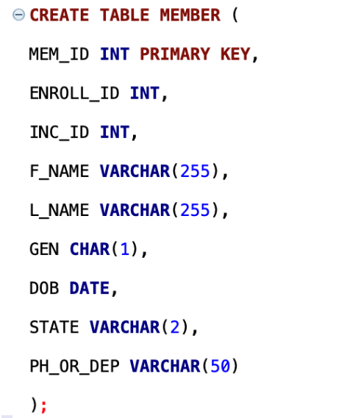

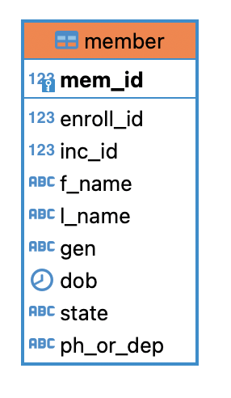

**-- Query For PLAN Table**

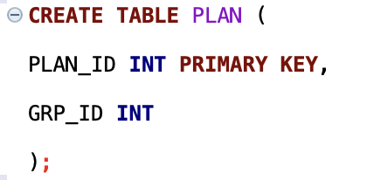

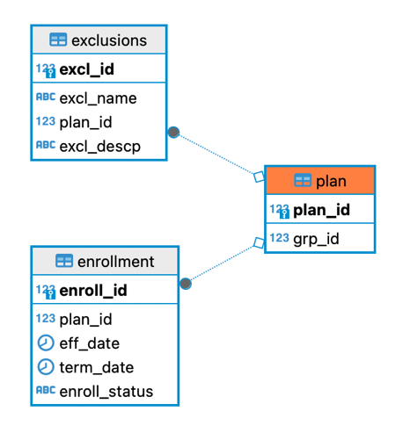

**-- Query For GROUPS Table**

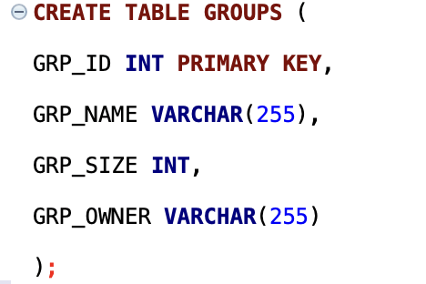

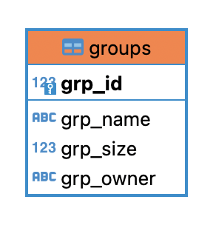

**-- Query For ENROLLMENT Table**

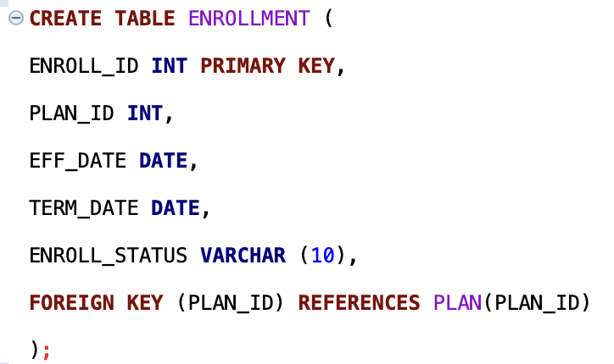

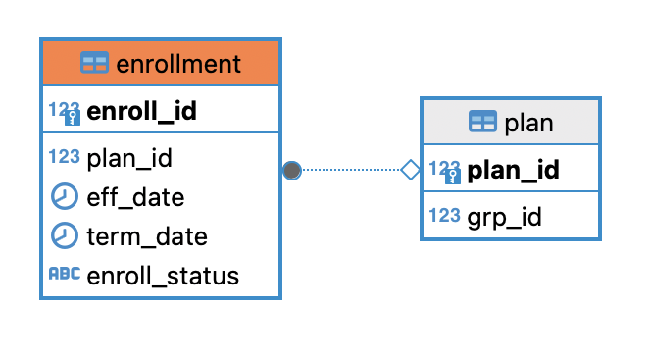

**-- Query For EXCLUSIONS Table**

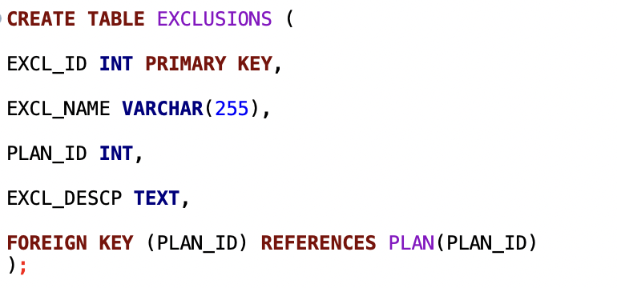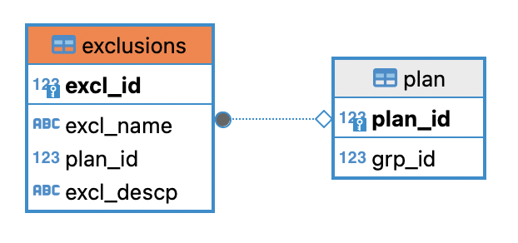

**-- Query For INCENTIVES Table**

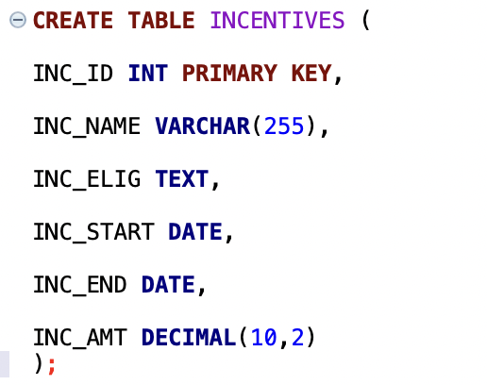

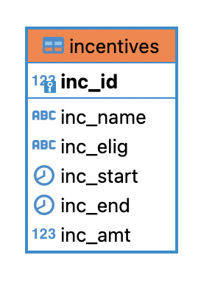

**Data Insertion:**

**-- Insert data into MEMBER Table**

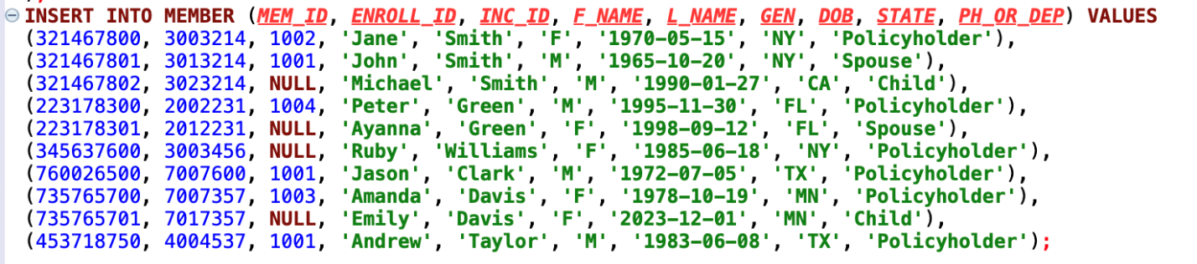

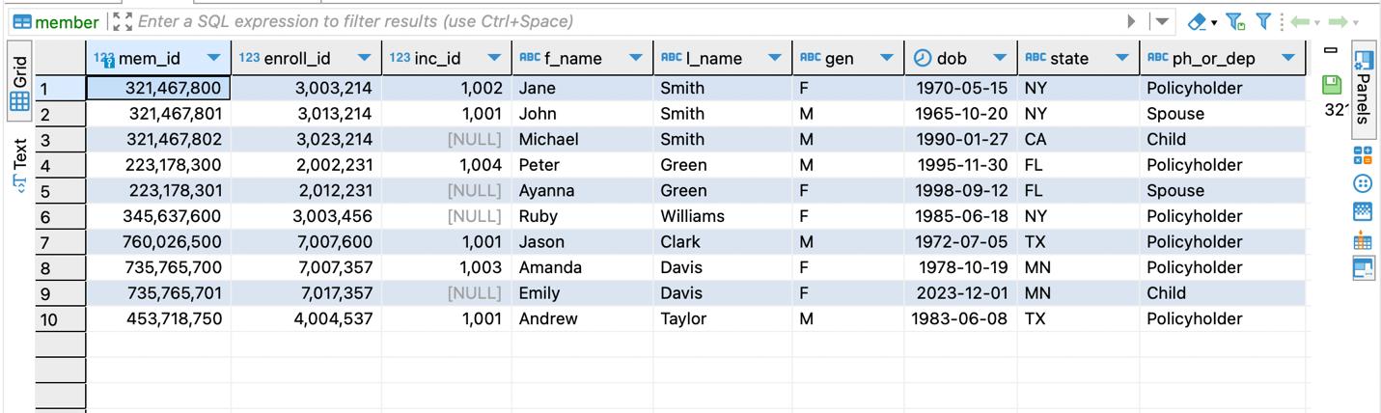

**-- Insert data into PLAN Table**

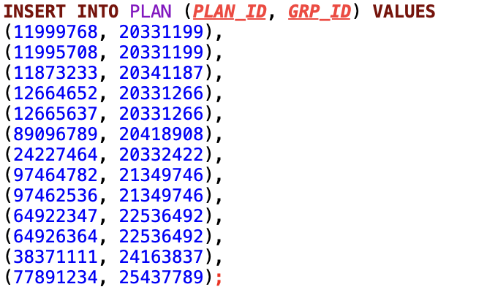

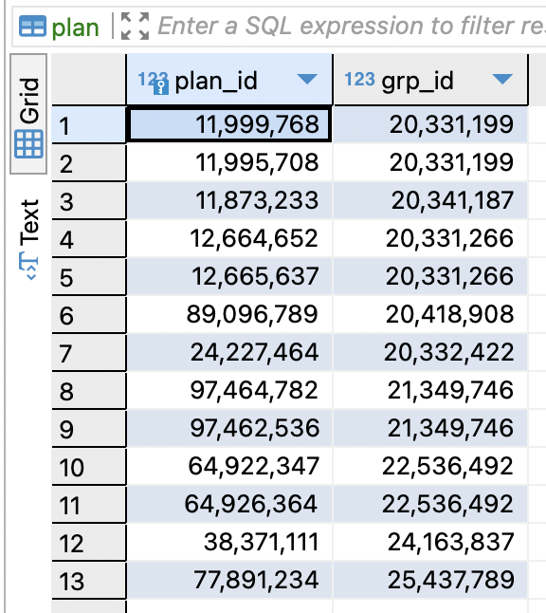

**-- Insert data into GROUPS Table**

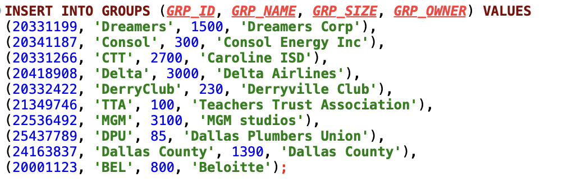

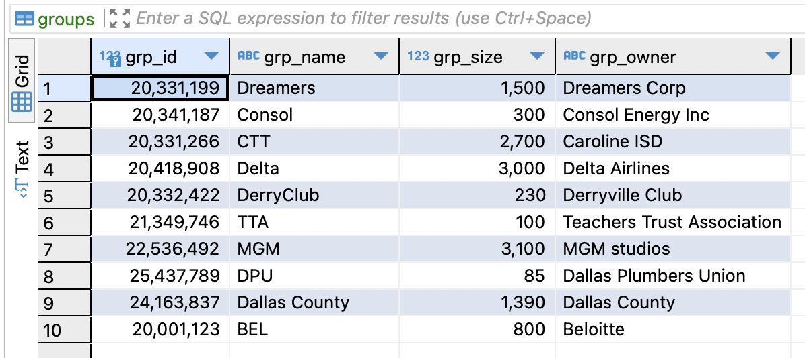

**-- Insert data into ENROLLMENT Table**

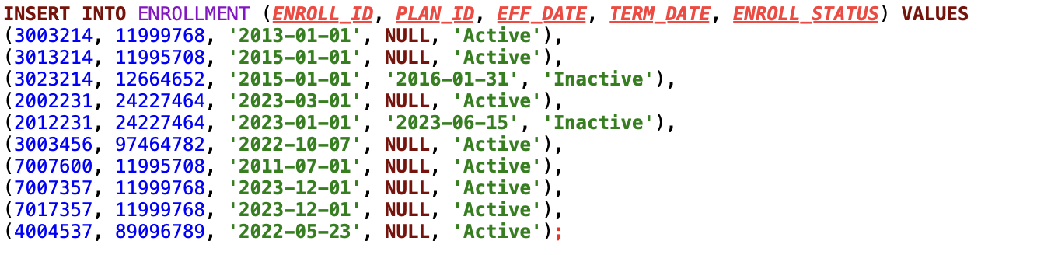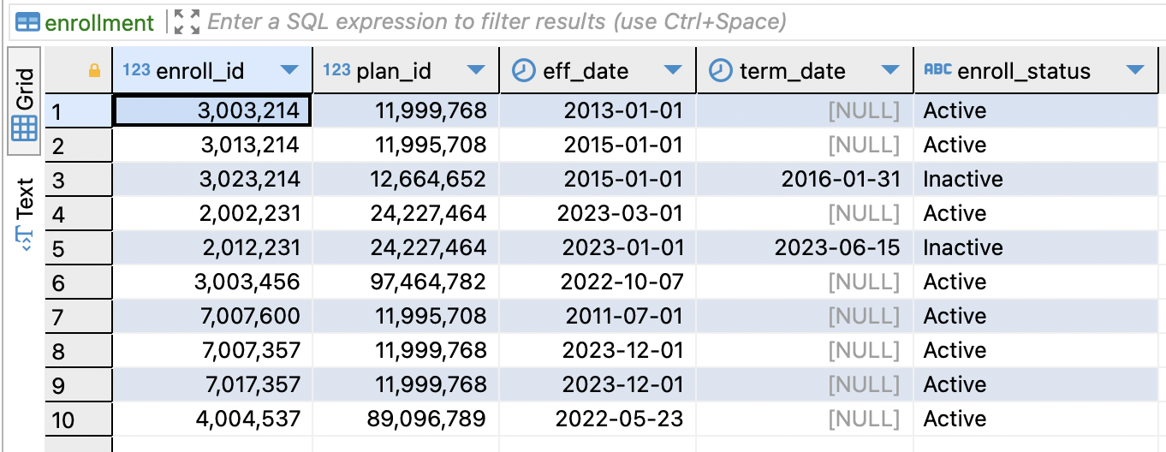

**-- Insert data into EXCLUSIONS Table**

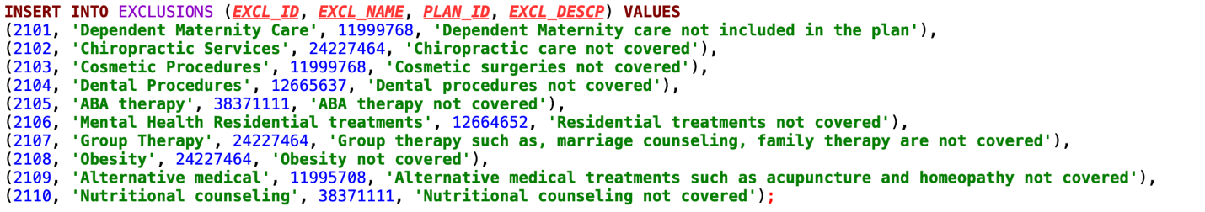



**-- Insert data into INCENTIVES Table**



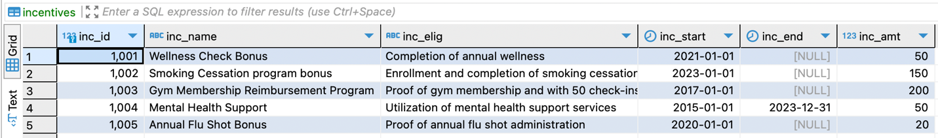

**Data Retrieval and Simple Reports:**

1. **Retrieve all members from New York (NY):**

**SELECT * FROM MEMBER WHERE *STATE* = 'NY';**

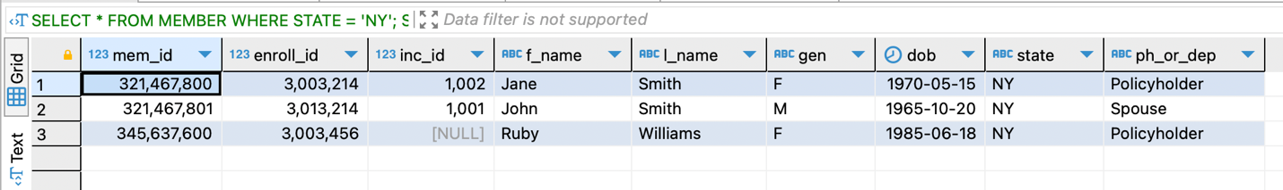

1. **List all active enrollments along with their effective dates:**

**SELECT ENROLL_ID, EFF_DATE, ENROLL_STATUS FROM ENROLLMENT WHERE ENROLL_STATUS = 'Active';**

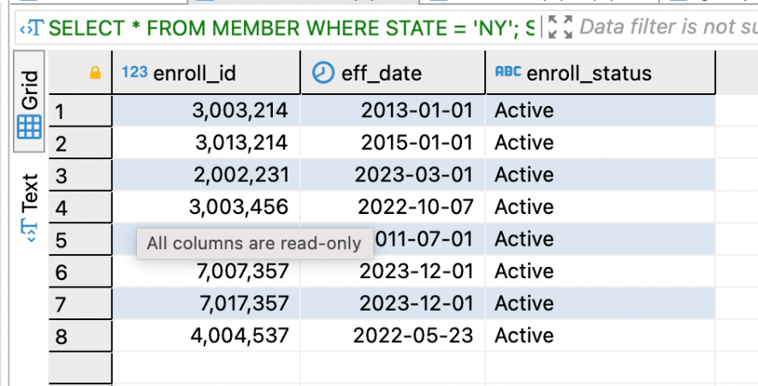

1. **Get details of members with their corresponding plan information:**

**SELECT *M*.*MEM_ID*, *M*.*F_NAME*, *M*.*L_NAME*, *P*.PLAN_ID**

**FROM MEMBER *M***

**JOIN ENROLLMENT *E* ON *M*.*ENROLL_ID* = *E*.ENROLL_ID**

**JOIN PLAN *P* ON *E*.PLAN_ID = *P*.PLAN_ID;**

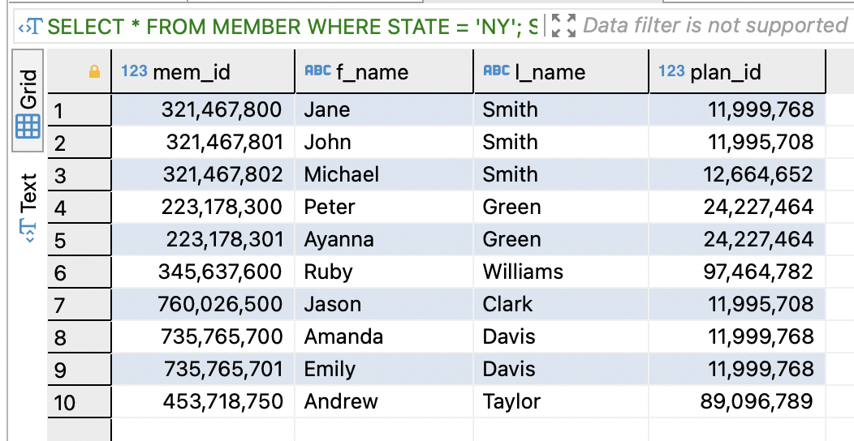

1. **Retrieve all groups with their sizes greater than 500:**

**SELECT * FROM GROUPS WHERE *GRP_SIZE* > 500;**

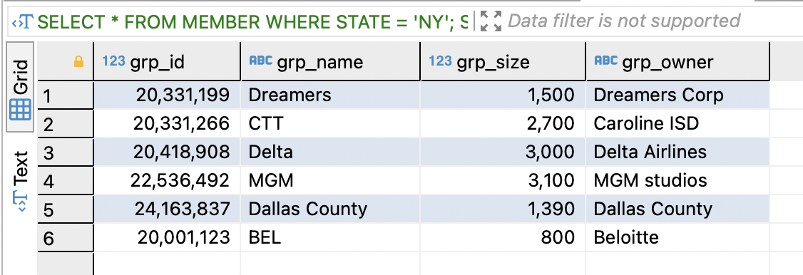

1. **List all incentives along with their eligibility criteria and amounts:**

**SELECT INC_NAME, INC_ELIG, INC_AMT FROM INCENTIVES;**

